PHASE 7 – PROJECT DOCUMENTATION
Project Title
Script-Controlled ACL – Restrict Record Access Based on Field Value

1. Project Documentation Overview
The project documentation provides a complete description of the Script-Controlled ACL project implemented in ServiceNow. It explains the purpose of the project, requirements, design, implementation, testing, and final outcome.
The documentation is prepared to provide a clear understanding of how Script-Controlled ACLs are used to restrict access to student records based on user roles and branch values.

2. Project Title
Script-Controlled ACL – Restrict Record Access Based on Field Value

3. Project Purpose
The purpose of this project is to implement Script-Controlled ACLs in ServiceNow to control access to student records based on user roles and branch values.
The system allows authorized users to access permitted records while restricting unauthorized access.

4. Technologies and Platform Used
Component | Technology
Platform | ServiceNow
Access Control | ACL
Scripting | ServiceNow ACL Script
Data Table | Student Records
Access Method | Role and Branch-based Access

5. Main Project Components
The main components implemented in the project are:
- Users and Roles
- Student Records table
- Branch-based student records
- Read ACL
- Write ACL
- Create ACL
- Delete ACL
- Script-controlled access conditions
- Administrator access
- Access verification

6. Project Implementation Summary
The project was implemented by first creating the required users and roles. A Student Records table was then created with branch information.
Records for different branches such as ECE, EEE, and CSE were added.
Script-Controlled ACLs were configured for Read, Write, Create, and Delete operations. The ACL scripts check the required access conditions before allowing users to perform the requested operation.

7. Access Control Documentation
The project uses ACLs to control different operations:
- Read ACL – Controls viewing of records.
- Write ACL – Controls modification of records.
- Create ACL – Controls creation of records.
- Delete ACL – Controls deletion of records.
The access decision is based on the configured user role and branch conditions.

8. Testing Documentation
Testing was performed using different users and roles.
The following areas were verified:
- Branch-based record access.
- User role-based permissions.
- Read operation.
- Write operation.
- Create operation.
- Delete operation.
- Administrator access.
- Unauthorized access restriction.
Screenshots of the configuration and testing results can be included as supporting evidence.

9. Screenshots and Evidence
The following screenshots should be included in the project documentation:

1. EEE User Created in ServiceNow
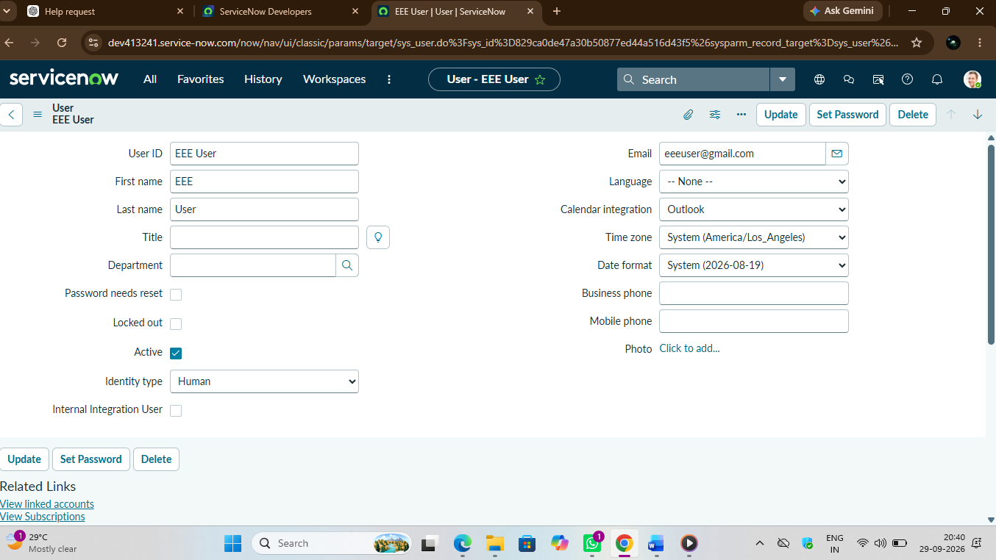

2. Role Assignment for EEE User in ServiceNow
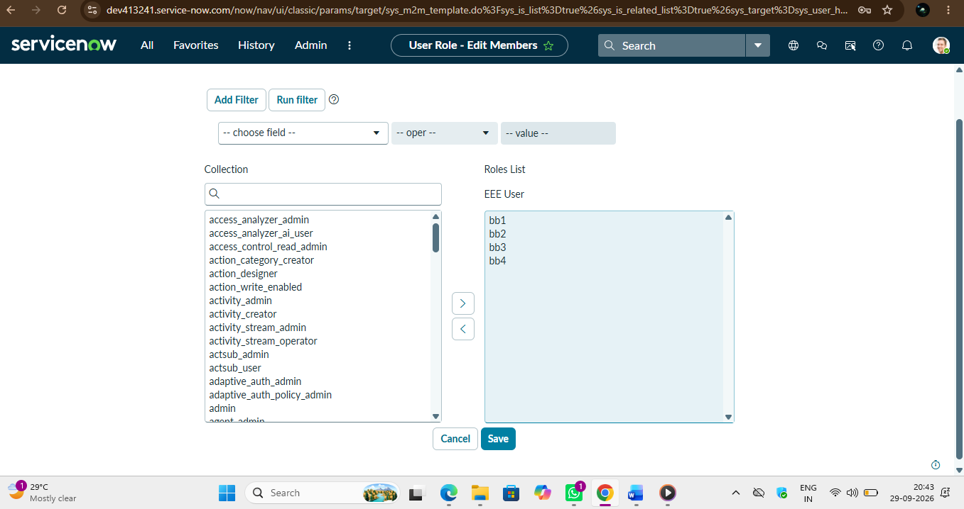

3. Student Records table
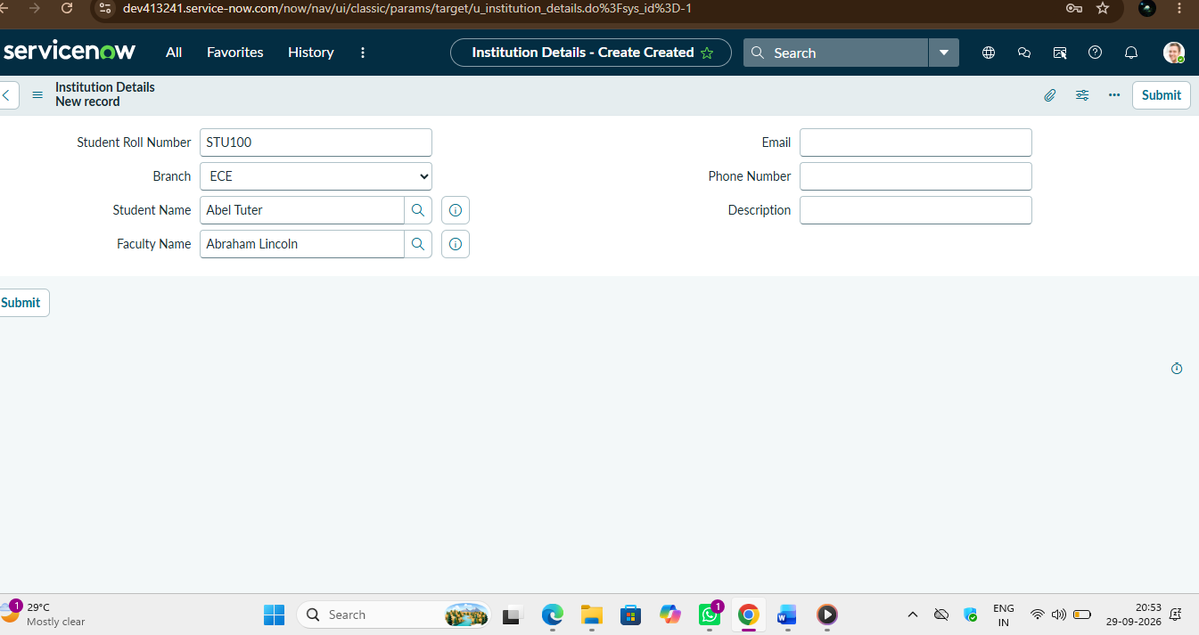

4. Branch-based student records
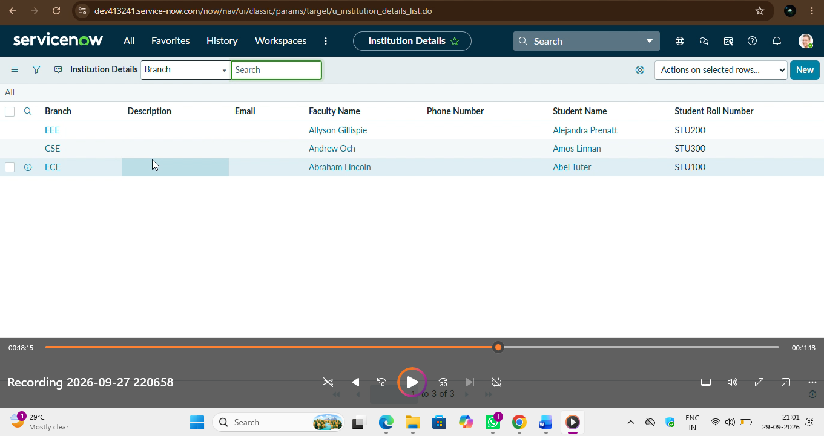

5. Read ACL configuration
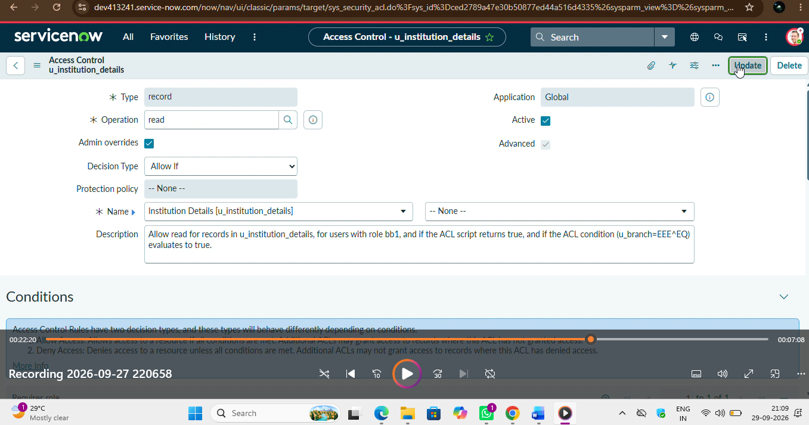

6. Write ACL configuration
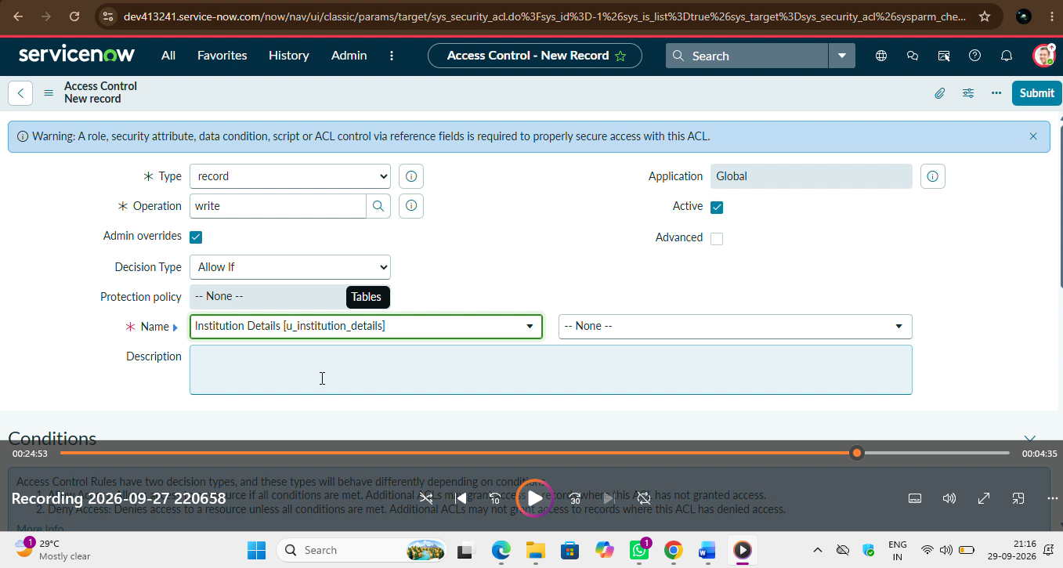

7. Create ACL configuration
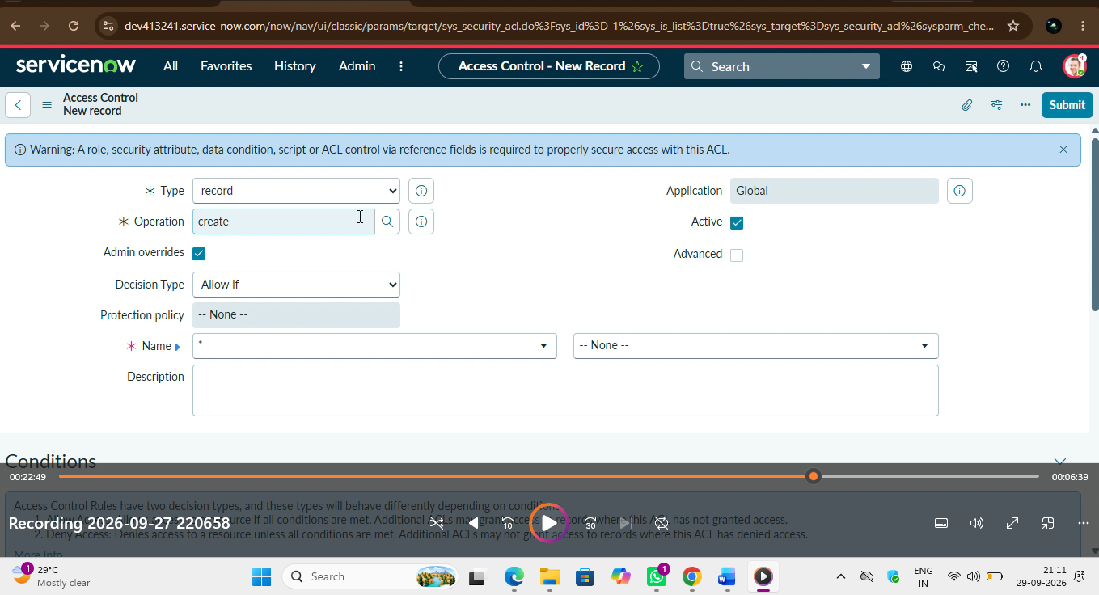

8. Delete ACL configuration
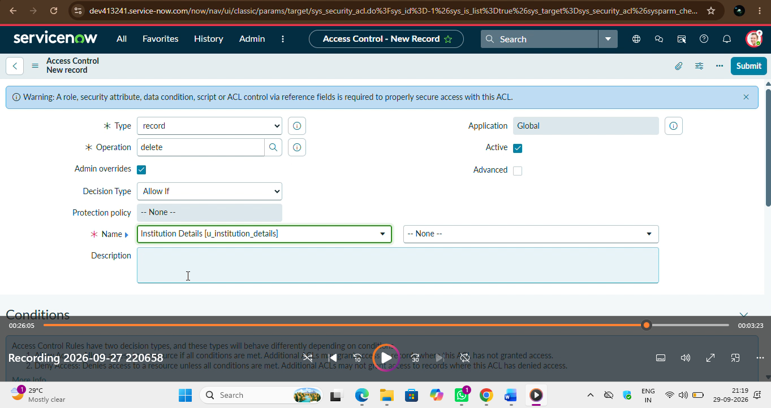

9. Access verification/testing
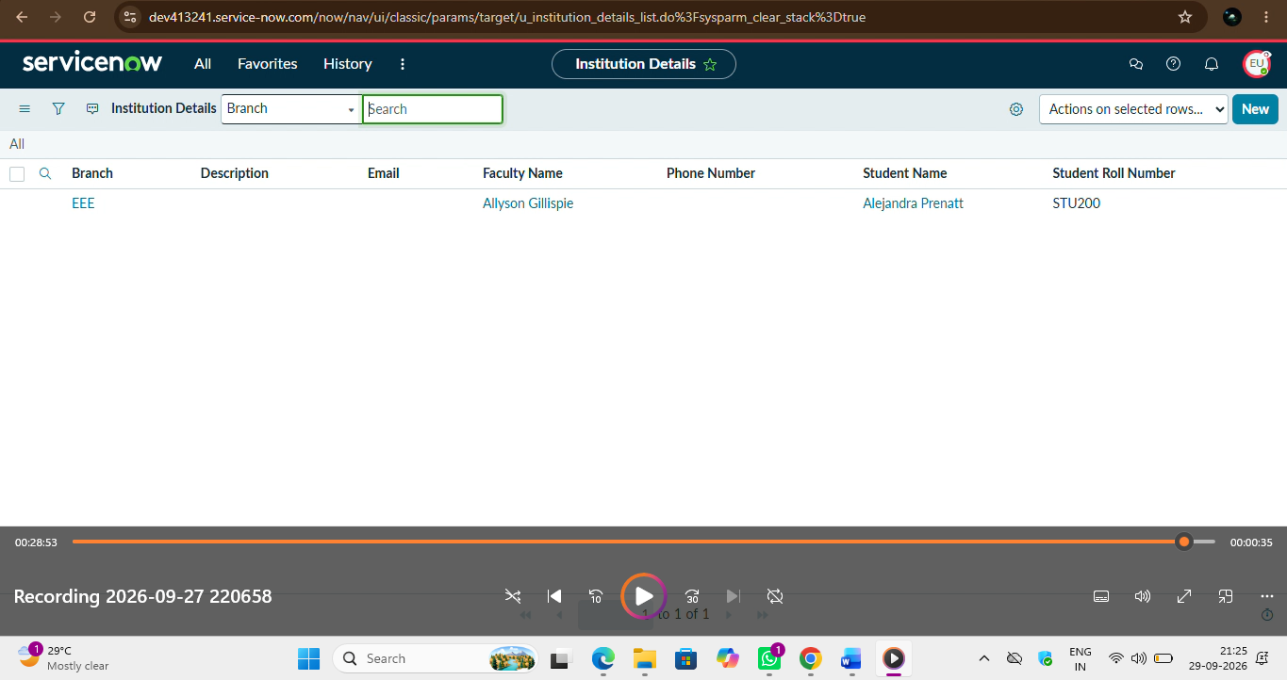

10. Final Project Outcome
- The completed project provides controlled access to student records using Script-Controlled ACLs.
- The system controls access according to the user's role and the branch value of the record. Different operations such as Read, Write, Create, and Delete are controlled through ACLs.
- Administrators are provided with the required full access, while unauthorized access is restricted.

11. Conclusion
The project successfully demonstrates the practical implementation of Script-Controlled ACLs in ServiceNow. It provides an understanding of how user roles and field values can be used to control access to records and protect information from unauthorized access.

